Python installation
Steps:1
Create folder in C: drive Name as Python
Steps:2
Install Python as 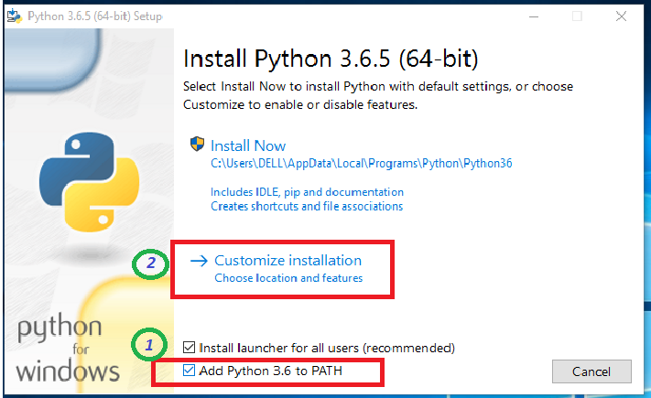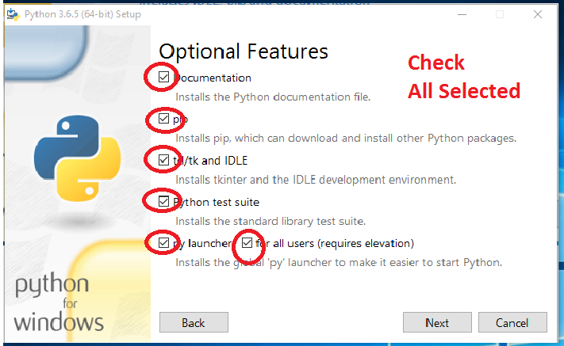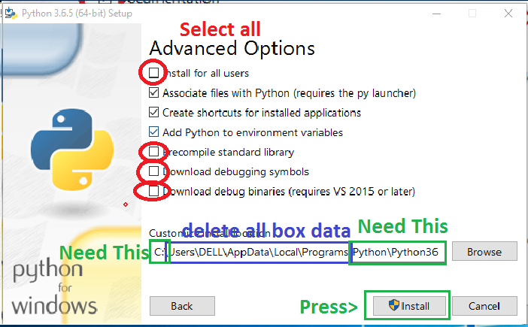 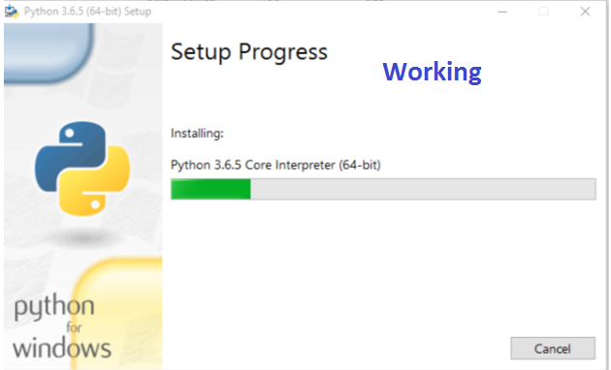wait………………………………………………………………………………………………
After Done:
Add Path in Window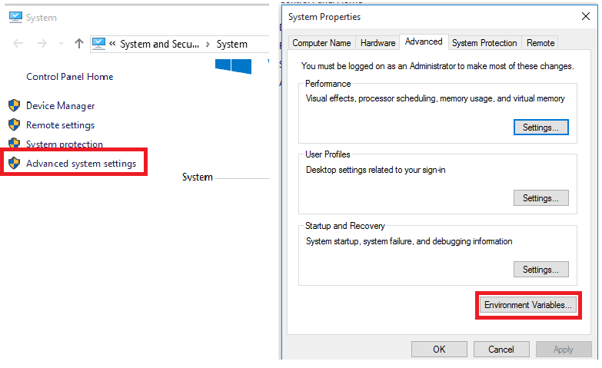
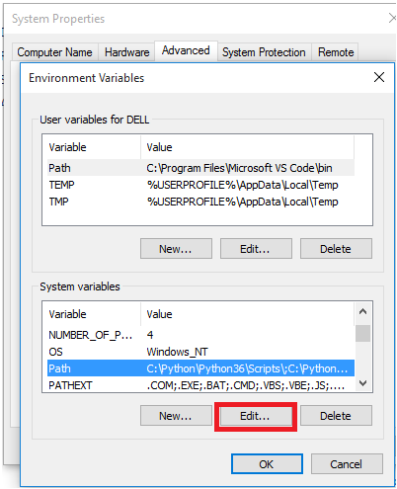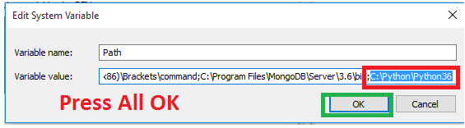
Open CMD
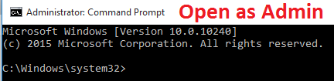
Type > PYTHON
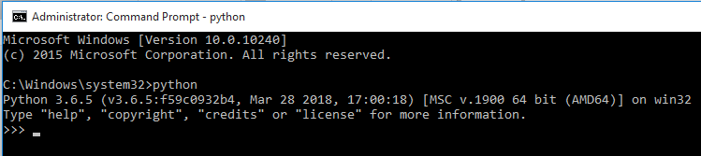
Close and open again run all pip commands as follows
INTERNET service activate first
pip install numpy
pip install SomePackage
pip install matplotlib
pip install scipy
pip install jupyter
pip install Django
pip install mysql or mysqlclient or mysql-python

